Create a dockerfile, docker-compose file which when executed must display your basic details in the website.

- CREATED THE DIRECTORY
- CREATED THE INDEX.HTML FILE FOR THE WEBSITE
- CREATED THE Dockerfile for copying the index.html file into NGINX html file.
- CREATED THE docker-compose.yml file for the site & Port configuration.
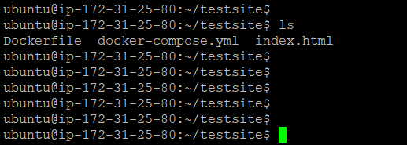
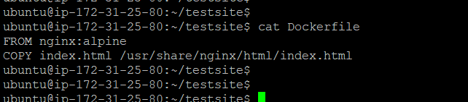

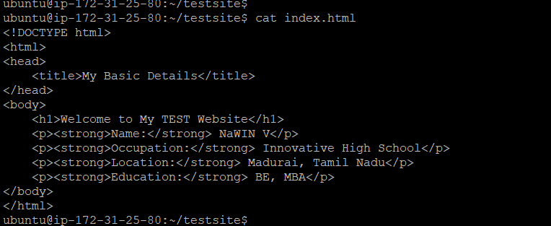
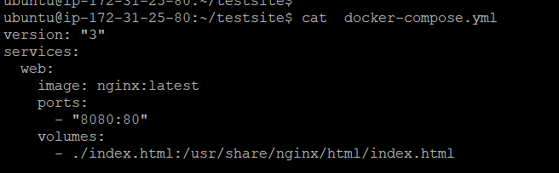
COMPOSED
sudo apt-get update
sudo apt-get install docker-compose-plugin
docker compose up -d
